Digital Design Diploma

# **Assignment 3 (Extra)**

# **Sequential Logic Design**

|  |  |
| --- | --- |
| **Name** | كريم حسن عاطف علي |
| **Group** | G2 |

**Submitted to: Eng. Kareem Waseem**

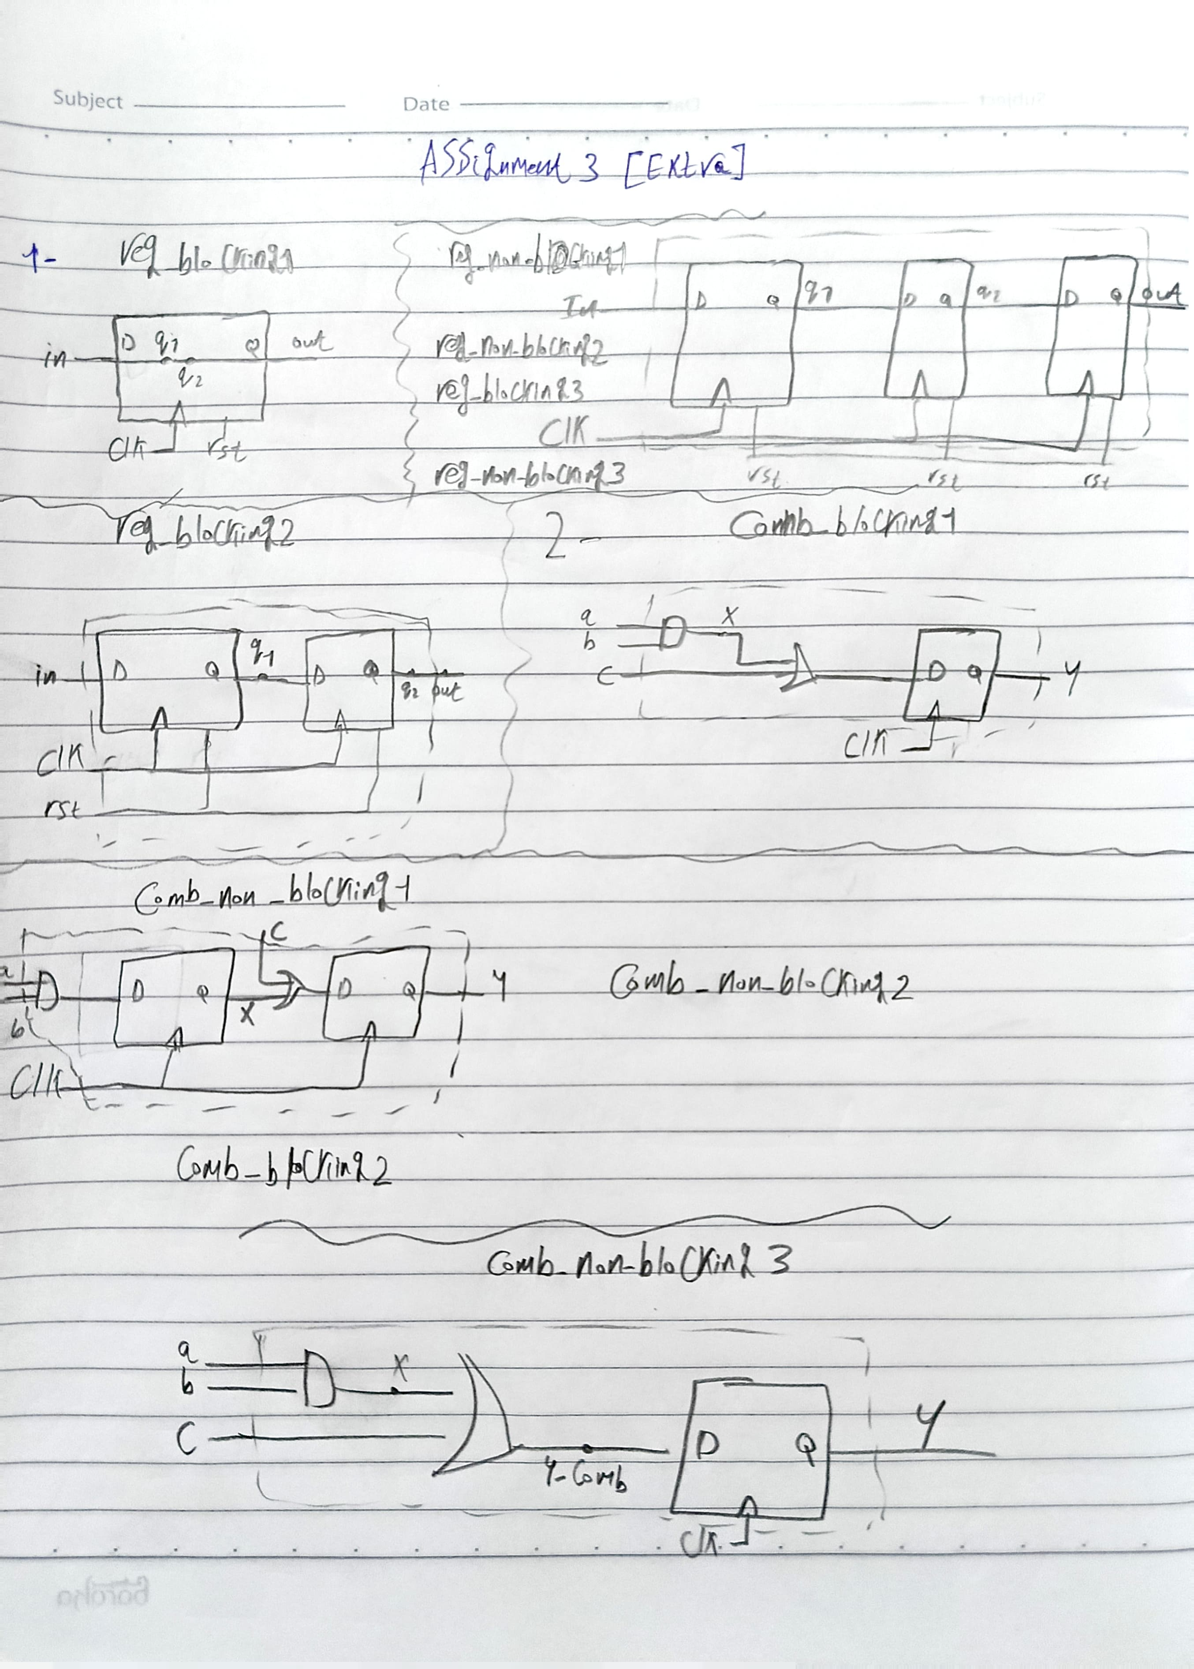

**2) 4-bit synchronous counter with asynchronous active low set:**

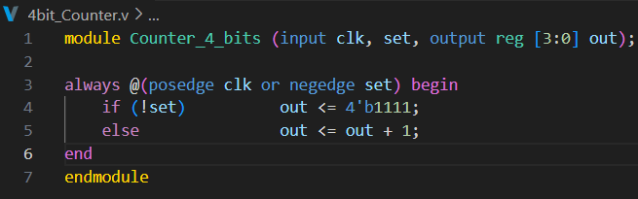

Figure1: Q2 Code

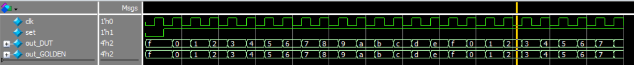

Figure2: Q2 Wave

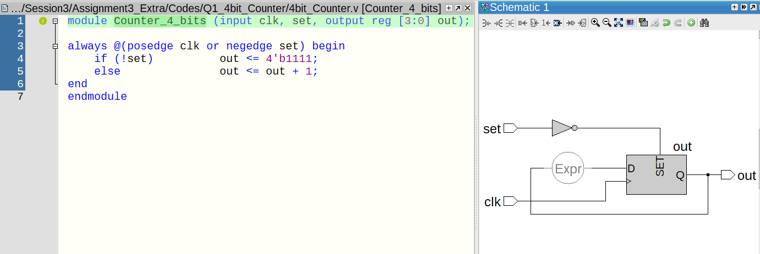

Figure3: Q2 Lint

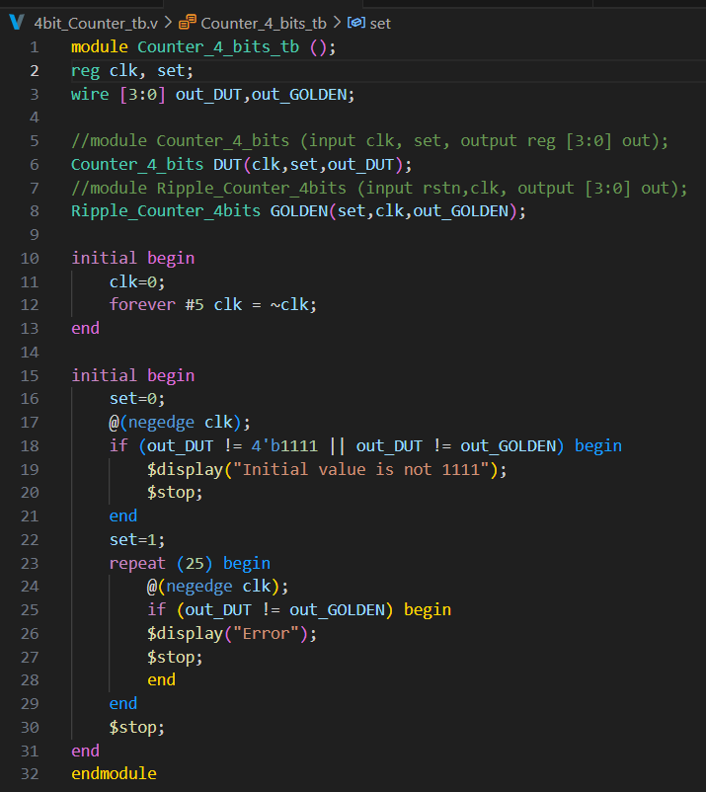

Figure4: Q2 Testbench

**3) Extended Counter:**

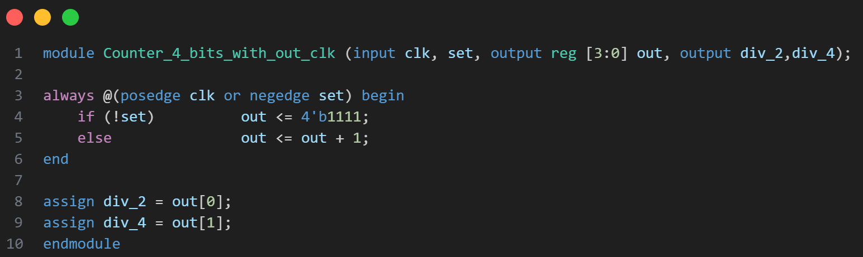

Figure5: Q3 Code

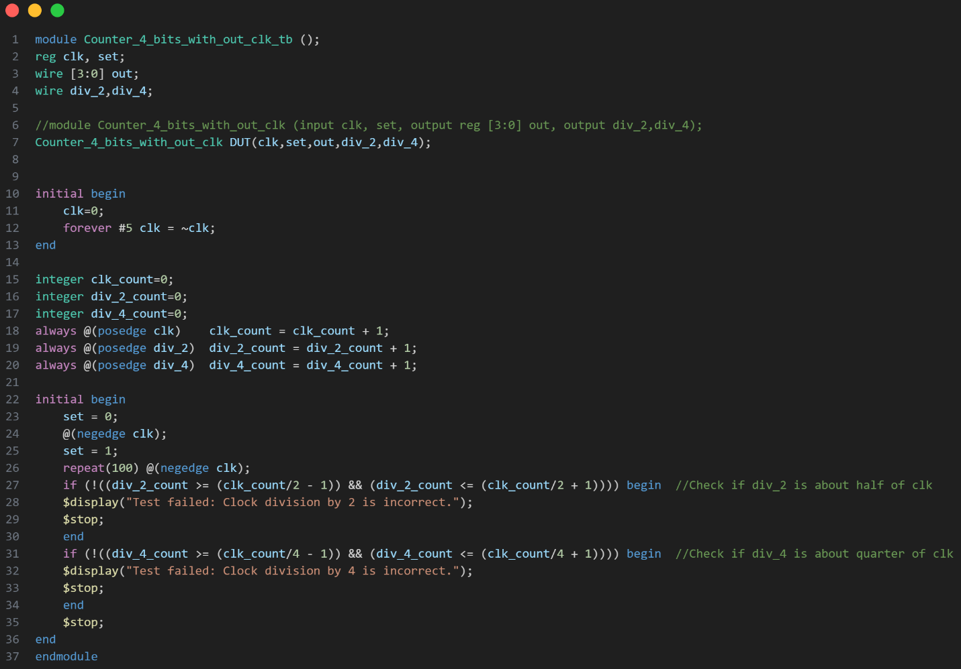

Figure6: Q3 Testbench

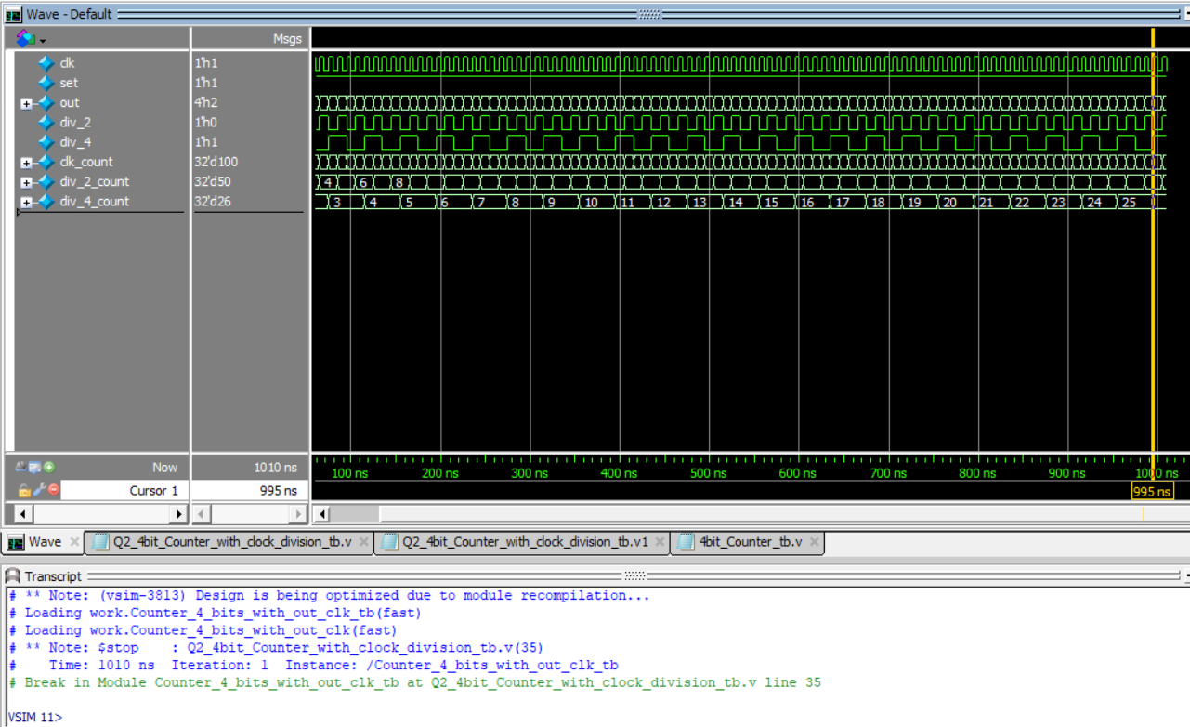

Figure7: Q3 Wave

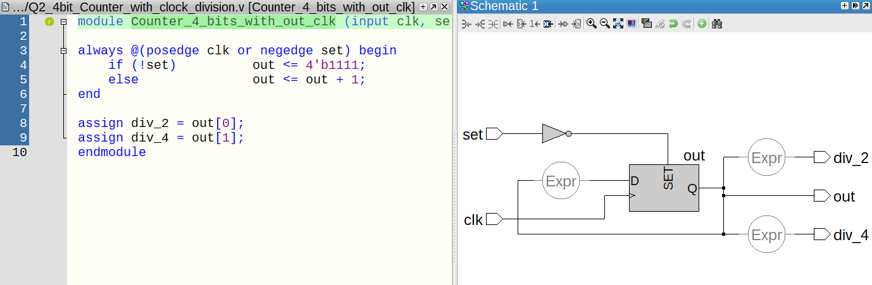

Figure8: Q3 Lint

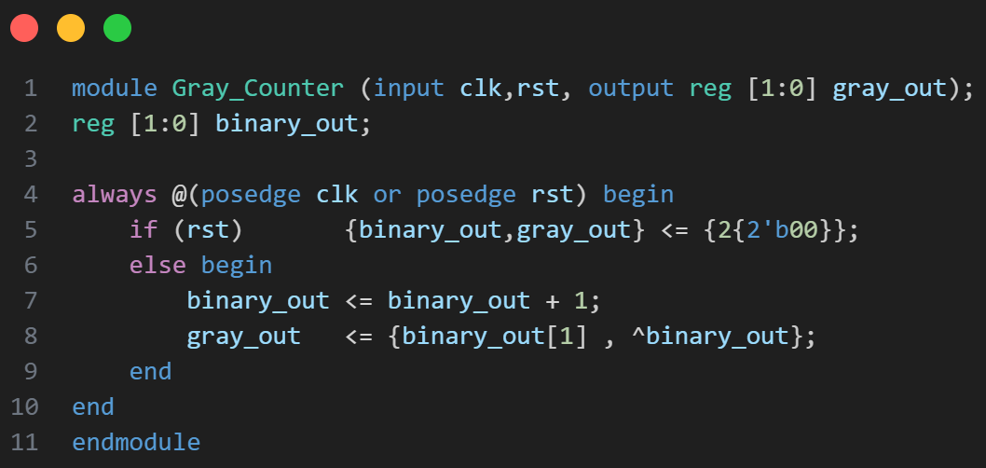**4) Gray Counter:**

Figure9: Q4 Code



Figure10: Q4 Wave

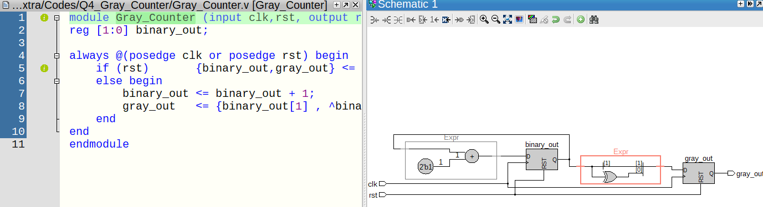

Figure11: Q4 Lint

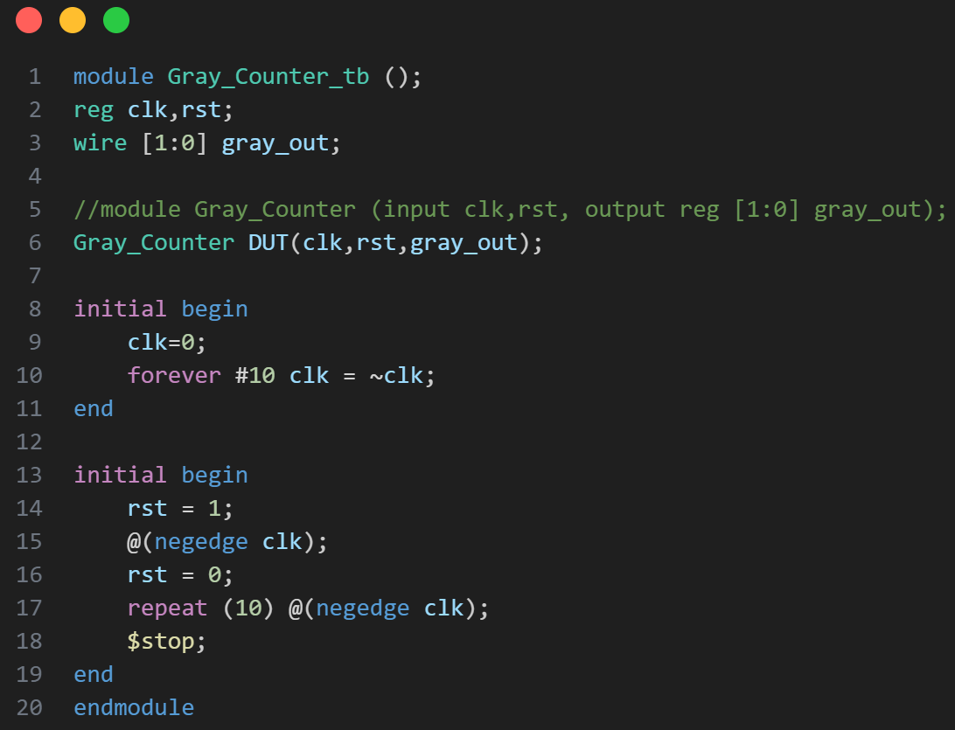

Figure12: Q4 Testbench